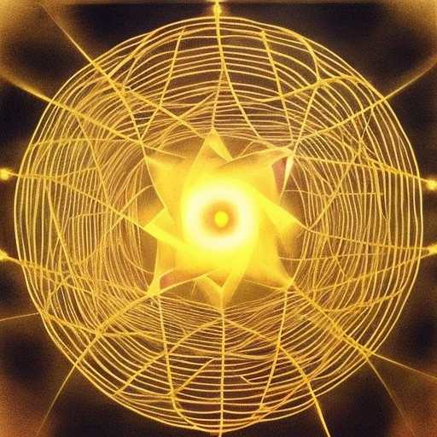
NODE BEYOND NETWORKS

My soul is a node beyond networks
It dances with golden star reflections upon the night river, weaved in
blankets of fates beyond understanding

This is yin
Letting oneself go to Samsara's water wheel of emotion

Floating in a basket to a royal princess with entourages of dancing dakinis to surpass

